THE MISPRICED RELIABILITY OPTION
Demand Flexibility and Untapped Alpha in Power Markets

MASE Capstone Research Paper
Johns Hopkins SAIS · Sustainable Energy Program
Chuk Ononogbu
Submitted: May 11, 2026

Executive Summary
This paper investigates whether demand-side flexibility is correctly valued by standard investment analysis. The short answer is no, but not in the way most people assume. Demand flexibility is the ability of businesses and homes to temporarily reduce their electricity use when the grid is under stress.

Demand flexibility earns almost nothing during the vast majority of hours when the grid is running normally. Its value is concentrated in rare emergencies when electricity scarcity prices spike dramatically. This payoff structure is identical to a financial option, an instrument that gives its holder the right to act when conditions are favorable and to do nothing when they are not. Standard investment analysis is not designed to value options correctly, and this paper shows exactly what that misvaluation looks like in practice.

Using seven years of real market data from the Texas electricity grid (ERCOT), this paper builds a mathematical model of how scarcity prices behave and runs 10,000 simulations of what a demand response portfolio might earn in a future year. The most striking finding is not an option value estimate. It is that a single 80-hour storm — Winter Storm Uri in February 2021 — contributed 48.6 percent of the entire three-year historical benchmark for that period. This means that less than one percent of the hours generated nearly half of the measured value. Any investment analysis that treats historical averages as a guide to future returns will be systematically misleading for an asset with this structure.

The paper also finds that demand flexibility's value rises directly in proportion to market volatility across every study period examined. This means demand flexibility is worth most precisely when and where the grid is under the most stress, which is exactly the property a well-designed reliability market should produce.

A NOTE FOR READERS NEW TO ENERGY MARKETS OR FINANCE
This paper uses concepts from both electricity markets and financial mathematics. If you are unfamiliar with either, the Appendix provides plain-language explanations of the key terms used throughout, including how ERCOT works, what an option is, and what the mathematical model does. You do not need a background in either field to follow the main argument — but the Appendix is there if any concept needs more context. Sections 1 and 3 are also written to be accessible without prior knowledge and are good starting points before diving into the methodology.

Table of Contents
Executive Summary 2
Table of Contents 3
1. Introduction 6
1.1 What is Demand Response? 6
1.2 The Problem with How We Value Demand Flexibility 6
1.3 Two Ways of Looking at the Problem 7
1.4 Why ERCOT, and the Research Questions 7
1.5 Contributions and Paper Structure 8
2. Literature Review 9
2.1 Scarcity Pricing and the ORDC 9
2.2 Demand Response: What We Know and What Is Missing 9
2.3 How Electricity Prices Behave: Modeling and Microstructure 10
3. Market Background: ERCOT and the ORDC 12
3.1 ERCOT: A Market Where Reliability Must Pay for Itself 12
3.2 How the ORDC Works 12
3.3 How Demand Resources Participate and Get Paid 13
3.4 The Three ORDC Regimes in the Study Window 13
4. Theoretical Framework 15
4.1 The Demand Response Portfolio 15
4.2 How the ORDC Adder Moves Over Time 15
4.3 The Option Payoff 16
4.4 The Valuation Problem and the NPV Gap 16
4.5 Sensitivity: The Greeks 17
4.6 Connection to Real Options Theory 18
5. Methodology 19
5.1 Data 19
5.2 Model Calibration 20
5.3 Monte Carlo Simulation 21
5.4 Portfolio Base Case and Sensitivity Analysis 23
6. Results and Analysis 24
6.1 Calibration Results and Model Fit 24
6.2 Where the Value Actually Comes From 25
6.3 Forward-Looking Option Values 27
6.4 Sensitivity Analysis 28
6.5 Vega: Volatility as the Primary Value Driver 29
6.6 Summary of Findings 30
7. Discussion 32
7.1 What the Results Mean for Demand Response Investment 32
7.2 Implications for Market Design 33
7.3 Limitations 33
8. Conclusion 35
References 37
Appendix: Key Terms and Concepts Explained 39
A.1 Electricity Market Basics 39
A.2 ORDC and Scarcity Pricing 40
A.3 Demand Response 41
A.4 Financial Options Concepts 41
A.5 Modeling and Simulation Concepts 42

Abstract
Demand-side flexibility is the ability of electricity users to temporarily reduce their consumption when the grid is under stress. This paper argues that this flexibility is a systematically mispriced asset: conventional investment methods value it by its average expected payments, but its true worth comes from its behavior during rare, high-stress moments when electricity prices spike dramatically. This payoff structure is identical to a financial option, and the gap between the option value and the conventional estimate represents a persistent source of untapped investment returns. Using the Electric Reliability Council of Texas (ERCOT) and its Operating Reserve Demand Curve (ORDC) as the empirical setting, we pursue two objectives: formally characterizing demand response as a call option on reserve scarcity prices, and analyzing the statistical behavior of ORDC price adders to show that their patterns are exploitable by flexible demand participants. A calibrated Monte Carlo simulation quantifies the option premium that conventional analysis ignores. I conclude by outlining how this mispricing could be captured through reliability-linked financial instruments.

1. Introduction

1.1 What is Demand Response?
Demand response is the practice of temporarily reducing electricity use during periods when the grid is under stress. Instead of always building more power plants to meet peak demand, grid operators can pay electricity users to voluntarily cut their consumption when supply runs tight. This typically happens during extreme weather events, unexpected generator outages, or periods of unusually high demand. Participants span a wide range: large industrial facilities like factories and data centers can shed significant amounts of load quickly, commercial buildings can dial back lighting and air conditioning through automated controls, and residential customers can participate through smart thermostats and electric vehicle charging schedules. In practice, individual participants are often too small to matter on their own, so third-party aggregators bundle together hundreds or thousands of flexible loads into portfolios large enough to be meaningful at the grid level. The result is a distributed, flexible resource that can respond to grid stress without requiring new generation infrastructure to be built.

1.2 The Problem with How We Value Demand Flexibility
Electricity grids always need a buffer of backup power so that if a generator unexpectedly trips offline or demand surges, the system stays balanced. This buffer is called operating reserves. When reserves run low, electricity prices can spike to thousands of dollars per megawatt-hour. The ability to temporarily reduce electricity consumption during those moments, known as demand-side flexibility or demand response, is one of the most valuable and underused tools available to grid operators. Yet it is consistently undervalued by the investment frameworks that determine how much money flows into building and maintaining it.

The problem is not with the technology or the market design. It is with the math used to evaluate demand response investments. Standard investment analysis asks: how much will this resource earn on average over its lifetime? But demand response does not earn money on average. While capacity payments provide a baseline income for being available, most of a portfolio's value comes from activation during rare grid emergencies when scarcity prices spike. This is the payoff structure of a financial option, which is an instrument that gives its holder the right but not the obligation to act when conditions are favorable. Options require a different kind of valuation, one that accounts not just for expected returns but for the value of having the choice to act. Standard net present value analysis has no mechanism for this, so it systematically underestimates what demand flexibility is worth and sends too weak an investment signal to the market.

This paper develops a framework to examine that gap precisely. By treating demand response as a call option on reserve scarcity prices and using real market data from ERCOT, the Texas electricity grid, we show that demand response value is highly concentrated in rare grid emergencies, and that this concentration is what makes both conventional analysis and simple historical benchmarks unreliable guides to future investment value.

1.3 Two Ways of Looking at the Problem
The first approach is option valuation. A company that can cut its electricity use on short notice holds the right, but not the obligation, to activate that curtailment during any given market interval. It makes sense to activate only when the payment for doing so exceeds the cost of curtailing load. This conditional, discretionary payoff is mathematically identical to a call option: it pays off when conditions are favorable and costs nothing when they are not. Once demand flexibility is framed this way, the full toolkit of derivative pricing applies, including the ability to measure how sensitive the option value is to price volatility, to portfolio size, and to activation costs.

The second approach examines how ORDC scarcity prices behave in practice. Looking at historical ERCOT data, the scarcity price signal shows three important patterns. First, it tends to revert to low levels quickly after spikes, reflecting the grid's ability to restore reserves. Second, volatile periods cluster together, meaning one spike tends to be followed by more. Third, occasional extreme jumps occur that are far larger than normal variation and account for most of the total option value. Understanding these patterns is essential for building a realistic simulation and for identifying when and how a flexible demand participant can best position itself to capture value.

1.4 Why ERCOT, and the Research Questions
ERCOT is the right place to study this problem for two reasons. First, it is the only major U.S. electricity grid that operates without a separate capacity market, meaning generators and demand resources must recover all their economic value through real-time prices. This makes the reliability value of demand flexibility fully visible in price signals rather than hidden in separate capacity payments. Second, ERCOT's ORDC is the most sophisticated real-time scarcity pricing mechanism in the United States. It calculates a price adder based on the actual probability that the grid will run out of reserves, multiplied by the estimated cost of a blackout. This makes the ORDC adder a direct, continuously updated measure of the reliability value of one additional megawatt of reserves at any given moment.

RQ1: Can demand-side flexibility within ERCOT's ORDC framework be formally characterized as a financial call option, and what mathematical model best describes how the scarcity price evolves over time?

RQ2: How does the forward-looking simulated value of a demand response portfolio compare to what historical data alone would suggest, and what does the gap between them reveal about how demand response value is distributed over time?

RQ3: How does the option value change as market volatility, portfolio size, and activation costs vary, and what does this mean for investment decisions and the design of new financial instruments?

1.5 Contributions and Paper Structure
This paper makes three contributions. First, it provides a formal option-pricing characterization of demand flexibility grounded in ERCOT's specific ORDC mechanics, extending prior work by Oren (2005) and Hogan (2005) from generation resources to demand-side portfolios. Second, it builds and calibrates a two-state Monte Carlo simulation that captures the real statistical behavior of ORDC adder dynamics, including the discovery that the adder is at or near zero approximately 96 to 98 percent of the time, extending the price modeling framework of Cartea and Figueroa (2005) and Weron (2006) to the specific context of reserve scarcity pricing. Third, it demonstrates empirically that simulated option value rises in direct proportion to market volatility across all three study regimes, confirming that demand flexibility is most valuable precisely when and where reliability risk is greatest, and that nearly half of the measured historical value in the highest-volatility period came from a single 80-hour event. Section 2 reviews the relevant literature. Section 3 explains ERCOT's ORDC mechanism in detail. Sections 4 and 5 develop the valuation theory and simulation methodology. Section 6 presents results. Sections 7 and 8 discuss implications and conclude.

2. Literature Review
This paper draws on three areas of research that have each made important contributions but have not been connected in the way this analysis requires: the economics of electricity scarcity pricing and the ORDC; the study of demand response programs and how they are valued; and the mathematical modeling of electricity price behavior. The gap this paper fills sits at the intersection of all three.

2.1 Scarcity Pricing and the ORDC
When electricity prices are capped below the true cost of a blackout, generators and reliability resources cannot earn enough revenue to justify their investments. This is the "missing money" problem, documented extensively by Joskow (2006, 2008). ERCOT's ORDC was designed directly in response to this problem. Hogan (2005) established the theoretical foundation: by setting a real-time price adder equal to the probability of losing load multiplied by the estimated cost of a blackout (the Value of Lost Load, or VOLL), the ORDC ensures that prices continuously reflect the true reliability value of reserves rather than jumping only at the moment of an actual outage. This design is what makes the ORDC adder an appropriate foundation for option pricing. Oren (2005) extended this logic to argue that reliability contracts function like call options for electricity suppliers, but did not develop a valuation framework for demand-side flexibility portfolios. The key limitation of the scarcity pricing literature is that it focuses on mechanism design and has not modeled the ORDC adder as a statistically characterizable time series.

2.2 Demand Response: What We Know and What Is Missing
Research consistently shows that demand flexibility is a meaningful reliability resource. Faruqui and Sergici (2010) found that customers on dynamic pricing programs reduced consumption during peak periods by 13 to 20 percent. Wolak (2011) showed that even modest demand-side price responsiveness reduces the frequency of price spikes. Borenstein (2005) demonstrated theoretically that the economic benefit of demand flexibility is largest precisely during high-price scarcity intervals, which is exactly when ORDC adders are elevated. The regulatory framework enabling demand resources to participate in wholesale markets has been built out through FERC Order 745 (2011), which required full market price compensation for qualifying demand response, and FERC Order 2222 (2020), which opened all wholesale market products to demand resource aggregations. The FERC (2021) Annual Assessment of Demand Response confirms that participation remains well below its potential despite these regulatory advances.

The critical missing piece is valuation methodology. Studies that evaluate demand response investments, including Faruqui, Sergici, and Akaba (2014), use standard cost-benefit or net present value methods that estimate value as the sum of expected payments under average conditions. This approach misses the option premium: the additional value that comes from having the choice to activate only when conditions are favorable and to hold back when they are not. Hirst and Kirby (2001) noted that demand response payoffs resemble a financial option, but did not develop this into a formal valuation method. No prior work has treated demand flexibility as a derivative on ORDC scarcity prices or used option pricing methods to estimate what the premium is worth.

THE CORE VALUATION GAP
Standard analysis estimates the expected payment from demand response. Option pricing estimates the risk-adjusted value of having the right to receive that payment only when conditions are favorable. The difference between these two numbers is the option premium. This paper measures that gap using real ERCOT data.

2.3 How Electricity Prices Behave: Modeling and Microstructure
Electricity prices behave differently from prices in most other markets. They tend to snap back to average levels quickly after spikes (mean reversion), show strong seasonal and daily patterns, occasionally jump to extreme values during supply shortages, and go through volatile periods that cluster together. Weron (2006) documents these patterns comprehensively and defines the standard benchmarks for any electricity price model. Schwartz (1997) established the Ornstein-Uhlenbeck process as the mathematical framework for mean-reverting commodity prices, and Lucia and Schwartz (2002) extended it to separate predictable seasonal patterns from random fluctuations, which is important for electricity given how strongly prices follow load cycles.

The most directly relevant prior model is Cartea and Figueroa (2005), who combined the mean-reverting framework with a Poisson jump process to capture the occasional large price spikes seen in electricity markets. Their model is the standard reference for pricing electricity derivatives, and this paper adopts it as the foundation for modeling the ORDC adder. Two adjustments are made: the model is calibrated using ERCOT ORDC settlement data specifically rather than total energy prices, and the jump parameters are estimated to reflect the institutional triggers of reserve scarcity rather than general supply-demand imbalances. Prior microstructure studies, including Huisman and Mahieu (2003) and Geman and Roncoroni (2006), model total settlement prices that mix the energy and scarcity components.

3. Market Background: ERCOT and the ORDC

3.1 ERCOT: A Market Where Reliability Must Pay for Itself
Most major U.S. electricity grids run separate capacity markets where generators receive payments just for being available, regardless of whether they produce power. ERCOT does not. As the only major U.S. grid operating without such a mechanism, ERCOT requires all resources, including demand-side flexibility, to recover their full economic value through real-time energy and ancillary service prices. This makes ERCOT the clearest test of whether scarcity pricing alone can correctly value reliability resources. It also means the ORDC adder is the primary channel through which demand flexibility earns its option value, making the adder's behavior directly relevant to everything that follows.

3.2 How the ORDC Works
ERCOT's ORDC was implemented in June 2014 to correct the missing money problem by ensuring that electricity prices rise continuously as reserves decline, rather than only at the moment of an actual blackout. Every 15 minutes, ERCOT calculates and publishes an adder that is added on top of the regular energy market price. The total amount a market participant receives is:
Settlement Price = Real-Time Energy Price + ORDC Adder
The ORDC adder is calculated using a reliability model. ERCOT estimates the probability that reserves will fall below the Minimum Contingency Level (MCL), the threshold below which involuntary customer outages would begin. That probability is called the Loss of Load Probability, or LOLP. The adder formula is:
ORDC Adder = VOLL × LOLP(Reserve Level)
Here VOLL is the Value of Lost Load, which represents the estimated economic cost to customers of a one megawatt-hour blackout. When reserves are plentiful, the LOLP is near zero and the adder is negligible. As reserves erode, the LOLP rises and the adder climbs toward VOLL. When reserves fall to or below the MCL, the LOLP is set to 1.0 and the adder equals VOLL in full. This creates the right-skewed, spike-prone payoff distribution that makes demand flexibility option-like in its value profile.

ERCOT also applies a conservative shift to its LOLP calculation, moving the distribution rightward so that the adder triggers at higher reserve levels than a neutral model would suggest. This shift was introduced at 0.25 standard deviations in 2019 and doubled to 0.5 standard deviations in 2020. Because the adder is computed and published independently for every 15-minute interval, it can be analyzed as its own time series, separate from the energy price, which is the key feature that allows the approach taken in this paper.

WHY THE ORDC ADDER IS THE RIGHT ASSET TO MODEL
Prior research models total electricity settlement prices, which mix together the energy dispatch price and the scarcity adder. For demand response option pricing, these need to be separated. The ORDC adder is the scarcity component in isolation: it is driven by reserve levels, calculated from a reliability model, and published independently by ERCOT. Modeling it separately is both a methodological contribution and a practical necessity for accurate valuation.

3.3 How Demand Resources Participate and Get Paid
ERCOT offers four ancillary service products through which demand resources can earn compensation for being available during stressful grid conditions. Responsive Reserve Service (RRS) requires a resource to respond within seconds to a frequency drop, essentially acting as an emergency brake on grid instability. It is the highest-value product for demand participants and can be provided through automated load curtailment triggered when grid frequency falls below a critical threshold. ERCOT Contingency Reserve Service (ECRS), introduced in June 2023, is a 10-minute response product designed to handle the increased uncertainty that comes with high levels of wind and solar generation. Non-Spinning Reserve Service requires availability within 30 minutes and is the most accessible product for loads that need advance notice before curtailment. Regulation Service provides continuous automated frequency control and requires fast telemetry infrastructure.

The compensation structure for these products maps directly onto the option framework. Day-ahead capacity payments, which resources earn simply for being available and qualified, are structurally equivalent to an option premium paid to hold the right to respond. Real-time dispatch payments during scarcity events, which include the elevated settlement price created by the ORDC adder, are structurally equivalent to the payoff a holder receives when they exercise the option. A demand aggregator holding RRS or ECRS capacity earns the premium in all hours and collects the full payoff during the rare intervals of elevated scarcity that dominate the distribution of total realized returns.

3.4 The Three ORDC Regimes in the Study Window
The 2018 to 2024 study period contains three distinct phases of ORDC operation, each with different parameter settings that affect the level and volatility of the adder. The first phase, from 2018 through early 2019, represents the original ORDC design before any parameter adjustments. The second phase, from mid-2019 through 2021, includes the 0.25 and then 0.5 standard deviation LOLP shifts ordered by PUCT and culminates in Winter Storm Uri in February 2021, during which ORDC adders held at or near their maximum value of $9,000 per megawatt-hour for more than 80 consecutive hours as the Texas grid came within minutes of a prolonged collapse. The third phase covers 2022 through 2024, following post-Uri reforms that reduced VOLL from $9,000 to $5,000 per megawatt-hour, raised the MCL from 2,000 to 3,000 megawatts, and introduced weatherization requirements. Section 5 estimates model parameters separately for each phase, and Section 6 reports option values across all three to show how the structural mispricing varies with the regulatory environment.

4. Theoretical Framework

This section formalizes the valuation problem introduced in Section 1. It defines the demand response portfolio, specifies how the ORDC adder evolves over time, and derives the option payoff expression that the simulation in Section 5 prices.

4.1 The Demand Response Portfolio
An aggregator manages a portfolio of N loads, each capable of reducing consumption by c megawatts (MW) when instructed. Because not every load is curtailable at every moment due to operating schedules and equipment constraints, each load is available with probability p in any given 15-minute interval. Each load's availability is a Bernoulli trial with probability p, so the number of available loads follows a Binomial(N, p) distribution. For a large portfolio (N sufficiently large), this is well approximated by a normal distribution:

Q ~ N(μQ, σ²Q) where μQ = N·p·c and σ²Q = N·p·(1−p)·c²
(4.1) Available portfolio capacity in MW
The mean μQ is the expected capacity available at any moment. The variance σ²Q reflects the fact that the aggregator cannot guarantee a fixed quantity in every interval. The simulation draws a fresh value of Q at each time step.

4.2 How the ORDC Adder Moves Over Time
The ORDC adder S(t) is modeled as a mean-reverting jump-diffusion process. Three forces act on it simultaneously: a pull back toward its long-run average (mean reversion), continuous small random fluctuations (diffusion), and occasional sudden large spikes (jumps). Together:

dS(t) = α(μ − S(t)) dt + σ dW(t) + J dN(t)
(4.2) ORDC adder dynamics
Here α controls how quickly the adder snaps back to its long-run mean μ after a spike, σ governs everyday random fluctuations, dW(t) represents continuous randomness, dN(t) is a Poisson process that registers jumps arriving at average rate λ per year, and J is the jump size drawn from an exponential distribution with mean μJ. Jump sizes are modeled as strictly positive, reflecting the asymmetric nature of ORDC scarcity pricing: reserve shortfalls cause prices to spike upward sharply, while recoveries happen through the mean-reversion term rather than negative jumps. This is consistent with the institutional design of the ORDC, where the adder floor is zero and upward spikes are driven by discrete events such as generator trips or sudden demand surges. Parameters are estimated separately for each of the three ORDC regimes from Section 3.4.

WHY THIS MODEL SPECIFICALLY
A simple random walk, where tomorrow's price is just today's plus a random shock, badly misrepresents ORDC adder behavior. An adder that spikes to $5,000/MWh reverts quickly once reserves recover. Without mean reversion the model overestimates how long elevated adders persist and inflates option value. Without jumps it smooths over the extreme spikes that generate most of the payoff. Both features are necessary for a credible simulation.

4.3 The Option Payoff
At each 15-minute interval t, the aggregator activates only when the ORDC adder S(t) exceeds the activation cost K. The activation cost K covers customer compensation, operational costs, and the opportunity cost of curtailed load. The payoff from one interval is:

Payoff(t) = max(S(t) − K, 0) · Q(t) · 0.25
(4.3) Interval payoff in dollars (Δt = 0.25 hours)
This is the call option payoff function: zero when the adder is below K, and equal to the margin above K otherwise. Summing over all T = 35,040 intervals in a year gives the total annual portfolio value:

V = Σ max(S(t) − K, 0) · Q(t) · 0.25
(4.4) Total annual portfolio value in dollars

4.4 The Valuation Problem and the NPV Gap
Because the adder's path through the year is unknown in advance, the portfolio's value today is the average payoff across all the paths the adder might plausibly take:

V₀ = E [ Σ max(S(t) − K, 0) · Q(t) · 0.25 ]
(4.5) Option value as an expectation under the physical probability measure
The Monte Carlo simulation in Section 5 estimates this by generating 10,000 possible adder paths under the physical probability measure — using parameters calibrated directly from historical data — and averaging the resulting annual payoffs.

The conventional NPV approach instead estimates value as:

V̂NPV = E[max(S(t) − K, 0)] · T · Q̅ · 0.25
(4.6) Conventional expected-value benchmark
where E[max(S(t) − K, 0)] is the expected per-interval payoff estimated from historical data, T = 35,040 is the number of intervals in a year, and Q̅ is mean available capacity. This is a more accurate benchmark than a formulation using the unconditional mean E[S(t)], since it correctly conditions on the activation decision. However, it still treats the expected payoff as fixed and uniform across all intervals, ignoring the path-dependent and time-varying nature of scarcity events. It also treats activation as automatic whenever S(t) exceeds K rather than as a discretionary choice.

The gap between V₀ and V̂NPV has two distinct components that this paper separates explicitly. The first is the true option premium: the convexity benefit of discretionary activation, which can be isolated by comparing E[(S−K)⁺] — the expected value of the option payoff — against (E[S]−K)⁺ — what a naive calculation using the average price would produce. Because the payoff function is convex in S, Jensen’s Inequality guarantees that E[(S−K)⁺] ≥ (E[S]−K)⁺, and the gap between the two represents the pure convexity value of optionality. The second component is rare-event sampling bias: when the historical period includes an extreme event like Winter Storm Uri, the historical benchmark embeds that event’s realized payoff as if it were a repeatable expected return, inflating V̂NPV in a way that has nothing to do with optionality. Section 6 decomposes the observed gap between V₀ and V̂NPV into these two components directly.

4.5 Sensitivity: The Greeks
Delta (Δ): How much the option value changes per dollar increase in the adder. Low in normal conditions, rising sharply as S(t) approaches K.

Vega (ν): How much the option value changes per unit increase in adder volatility. Vega is always positive: more volatility means a higher chance of the large spikes that generate the biggest payoffs. This is the most important Greek for this paper's argument — demand flexibility is worth most during high-stress, high-uncertainty market conditions.

Theta (Θ): How much value the option loses as the operating year progresses. Fewer remaining intervals means fewer opportunities for a favorable spike. Unlike a financial option, this resets at the start of each new year.

Section 6 estimates Vega empirically across the three regimes and confirms that simulated option value rises in direct proportion to market volatility, with the highest-volatility regime producing the highest option value.

4.6 Connection to Real Options Theory
This framework applies real options theory, the branch of finance that extends option pricing to physical assets and investment decisions. Dixit and Pindyck (1994) showed that investment opportunities are worth more than conventional analysis suggests when three conditions hold: the commitment involves some irreversible cost, the future payoff is uncertain, and the decision-maker has discretion over timing. A demand response portfolio satisfies all three. Prior real options work in electricity has focused on generation assets. What makes the demand-side application possible here is the ORDC adder — a precisely defined, publicly observable price that serves as the underlying asset. Prior demand response studies that noted the option-like structure of DR payoffs (Hirst and Kirby, 2001) lacked an equivalent underlying asset to anchor a formal valuation. The ORDC provides that foundation.

5. Methodology

Section 4 set up the valuation problem. This section describes how it is solved. There are four steps: obtaining and cleaning the data, estimating the model parameters, running the simulation, and measuring uncertainty in the results.

5.1 Data
The data source is ERCOT's publicly available Real-Time Market records. ERCOT publishes the Real-Time On-Line Reserve Price, which is the ORDC adder applied to all real-time energy settlements, for every 15-minute interval. This paper uses that series exclusively, since it reflects the compensation available to demand resources that can respond within the current dispatch window.

The study period runs from January 1, 2018 through December 31, 2024. After removing a small number of missing or corrupted intervals (less than 0.4% of the total), the cleaned dataset contains approximately 209,000 usable observations. The three regimes from Section 3.4 are applied as breakpoints: Regime 1 (January 2018 through February 2019), Regime 2 (March 2019 through December 2021), and Regime 3 (January 2022 through December 2024). The 267 intervals covering Winter Storm Uri in February 2021 are excluded from calibration but used separately as a stress test, since including Uri would cause the model to overstate normal jump frequency.

Before calibration, predictable seasonal patterns are removed from the raw adder series. Summer afternoons in Texas carry systematically higher adder values than overnight hours in spring because reserve margins are tighter when air conditioning load peaks. These patterns are foreseeable and not part of the random variation the model is meant to capture. A seasonal mean is estimated for each hour-of-day and month-of-year combination and subtracted from the raw series. The residual is what gets calibrated.

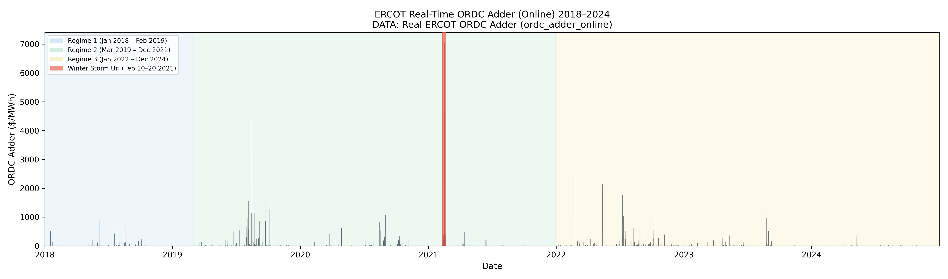
Figure 1: ORDC adder time series across the study period. Shaded regions indicate the three regimes. The red band marks the Winter Storm Uri period (February 2021). Note the near-zero baseline and occasional extreme spikes.

5.2 Model Calibration
The stochastic process in equation 4.2 has five parameters to estimate: long-run mean μ, mean reversion speed α, diffusion volatility σ, jump arrival rate λ, and mean jump size μJ. Calibration follows four steps, applied separately to each regime.

Step 1. Estimate μ as the sample mean of the deseasonalized adder series. Estimate α by running an AR(1) regression of S(t) on S(t−1). The regression coefficient b gives α = −ln(b)/Δt. A higher α means faster reversion after a spike.

Step 2. Separate jumps from diffusion. Any regression residual larger than three times the robust standard deviation is flagged as a jump and set aside. This threshold is a practical heuristic rather than a statistically optimal classifier. It may be sensitive to volatility clustering: during periods of sustained high volatility, large diffusion shocks can be misclassified as jumps, potentially overstating jump intensity. Robustness to alternative thresholds (2.5-sigma and 3.5-sigma) is checked and reported in Section 6.

Step 3. Estimate σ as the standard deviation of the remaining non-jump residuals, scaled by 1/√Δt.

Step 4. Estimate λ as the number of flagged jumps per year. Estimate μJ as the average size of those jumps. Jump sizes follow an exponential distribution, which matches the right-skewed tail structure of observed ORDC spikes.

Model fit is checked by comparing simulated and historical adder distributions using QQ plots and the Kolmogorov-Smirnov test. If the fit is poor, the jump threshold is adjusted and the steps are repeated. It should be noted that this calibration procedure is a practical moment-matching approach rather than a full maximum likelihood estimation (MLE). A formal MLE would jointly optimize all five parameters simultaneously and provide standard errors for each estimate. The stepwise approach used here is more transparent and computationally tractable, but may produce parameter estimates that are locally rather than globally optimal. This limitation is acknowledged as a direction for future refinement.

An important finding emerged during calibration: approximately 96 to 98 percent of all ORDC adder observations are at or near zero. The grid is adequately resourced the vast majority of the time and the scarcity adder essentially does not activate. This caused the standard IQR-based dispersion measure to collapse to near zero, incorrectly flagging almost all non-zero values as jumps and producing implausible jump intensities of over 6,000 per year. To address this, the calibration was modified to use a two-state structure following Huisman and Mahieu (2003). Formally, at each interval t the system state is drawn as an independent Bernoulli random variable: I(t) ~ Bernoulli(p_active), where p_active is the empirically estimated probability of the active state. When I(t) = 0, the adder is set to zero (quiet state). When I(t) = 1, the adder evolves according to the mean-reverting jump-diffusion process in equation 4.2 (active state). This discrete state selection approximates a continuous-time regime-switching process, with the advantage of being directly calibrated from observed interval frequencies. The OU+jump process is calibrated on active intervals only. This change reduced the KS statistic from approximately 0.97 to 0.07 to 0.09 and brought jump intensity down to a plausible 19 to 27 events per year.

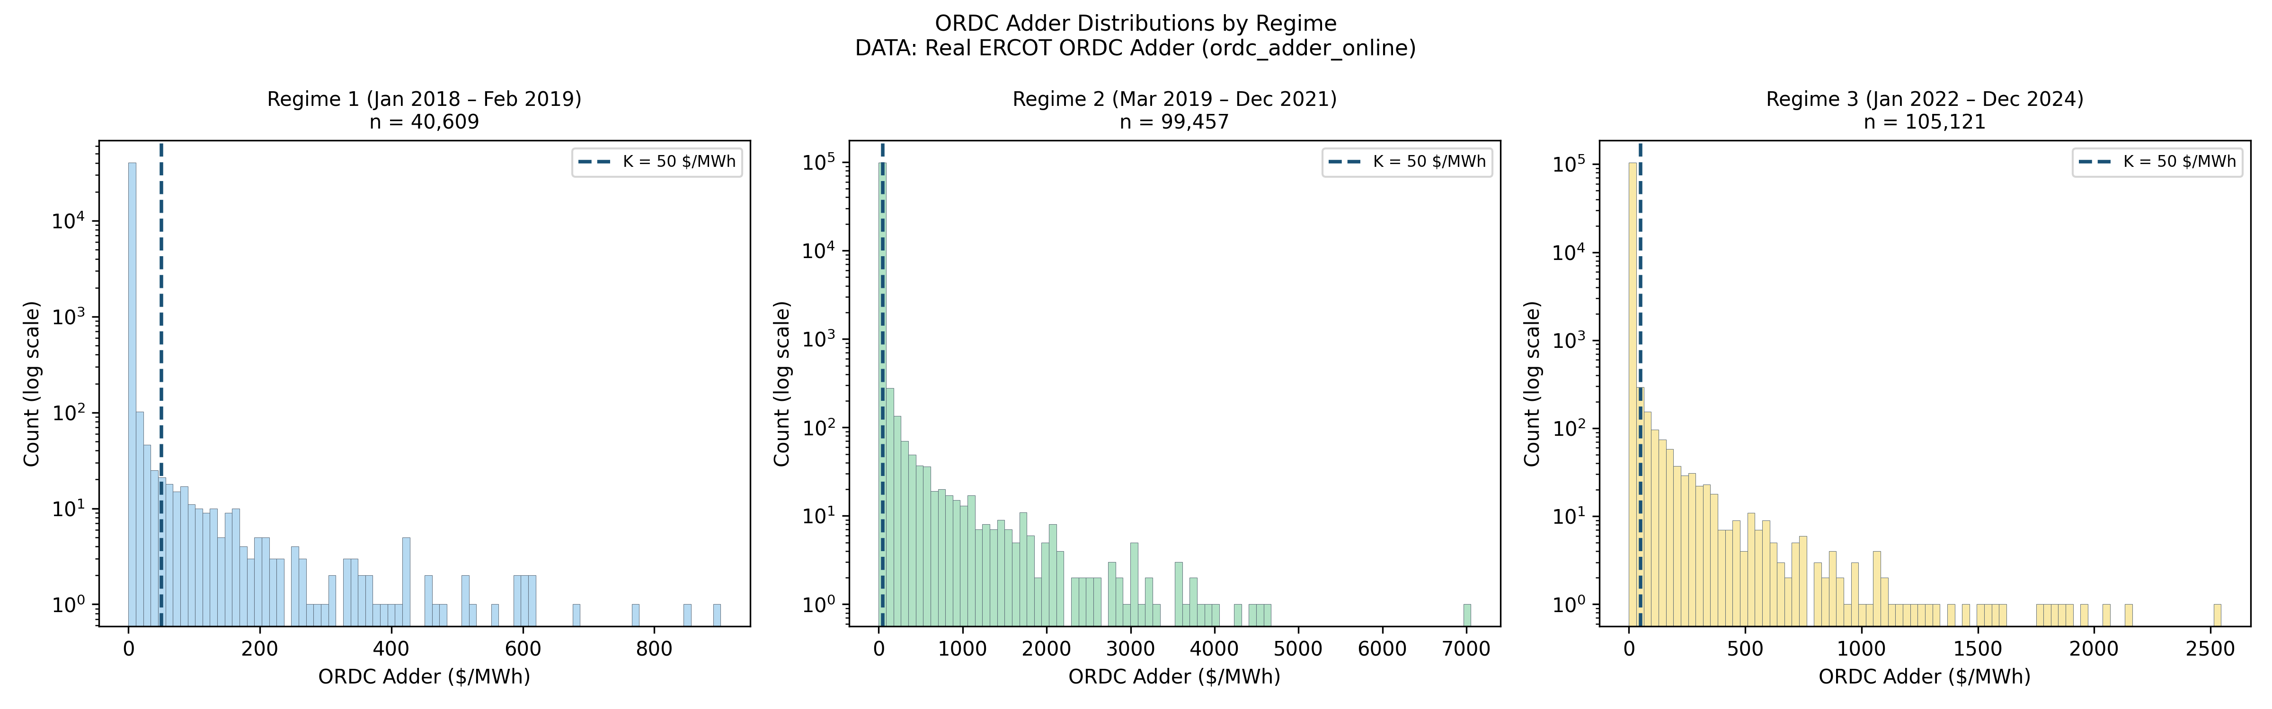
Figure 2: Distribution of ORDC adder values across the three regimes on a log scale. The vertical dashed line marks the base case activation cost of $50/MWh. The heavy mass at zero is visible in each panel.

5.3 Monte Carlo Simulation
The simulation generates 10,000 independent paths of the ORDC adder through a full year of 35,040 intervals using the two-state structure described in Section 5.2. At each interval, the system is first assigned to either the quiet state, where the adder is set to zero, or the active state with the probability estimated from each regime’s historical data. In the active state, the adder evolves as described below. The option value estimate is the average annual payoff across all paths.

Each path advances one interval at a time using the discretized version of equation 4.2:

S(t+1) = S(t) + α(μ − S(t))Δt + σ√Δt · Z + J · B
(5.1) Simulation update step
Z is a standard normal draw, B is 1 with probability λΔt (a jump arrives) and 0 otherwise, and J is an exponential draw with mean μJ when B = 1. After each step, the adder is clipped to [0, VOLL]. This clipping is a numerical constraint that reflects ERCOT market rules — the adder cannot be negative and cannot exceed the Value of Lost Load cap — rather than an intrinsic property of the stochastic process itself. The underlying SDE in equation 4.2 is defined on the full real line; the bounds are enforced at the simulation layer to ensure the modeled prices remain within the feasible range set by ERCOT’s tariff. At the same step, available capacity Q(t) is drawn from equation 4.1. The interval payoff from equation 4.3 is computed and accumulated. After all 35,040 steps, one annual value V is recorded. The option value V₀ is the mean of all 10,000 annual values. Two limitations of this implementation are worth noting: the Euler discretization introduces approximation error relative to the continuous-time SDE, and the calibrated parameters are treated as fixed across each regime, which does not capture any gradual parameter drift within a regime. Both are acknowledged as directions for future refinement.

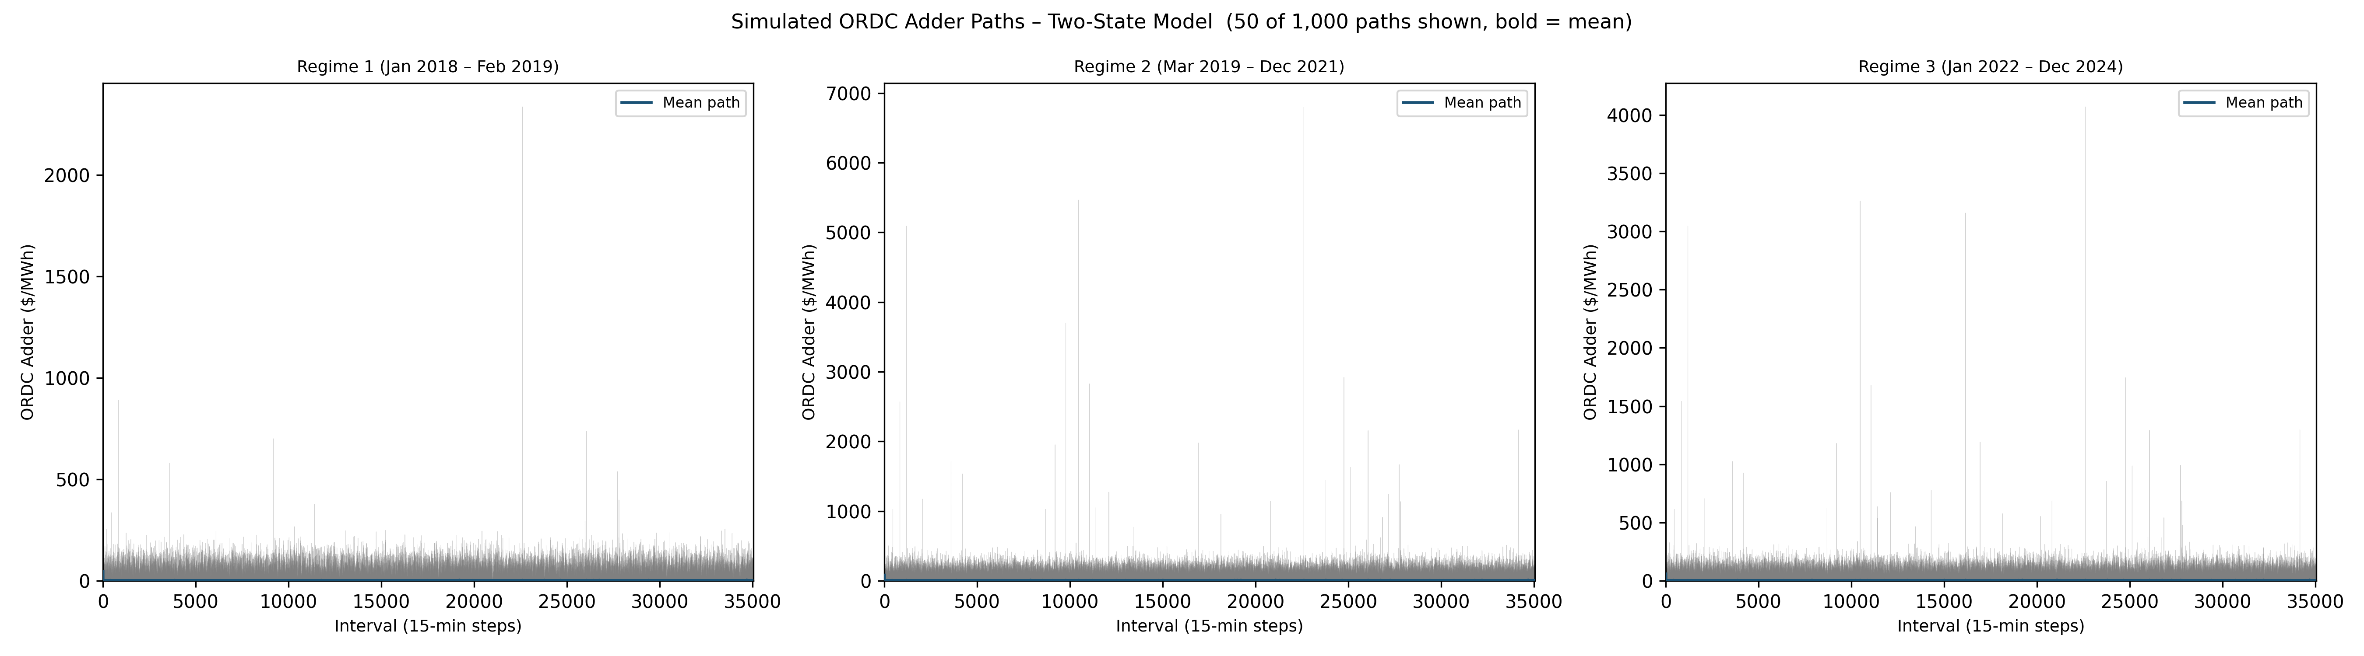
Figure 4: One hundred simulated ORDC adder paths per regime (thin gray lines) with the mean path overlaid in blue at essentially the near-zero baseline. The near-zero baseline and occasional spikes are visible across all three panels.

5.4 Portfolio Base Case and Sensitivity Analysis
The portfolio is specified using assumed parameters rather than data from a specific real-world program, keeping the framework general. The base case is:

- N = 100 loads, c = 1 MW per load, p = 0.80 availability probability
- K = $50/MWh activation cost
- Mean available capacity: μQ = 80 MW

All results are reported in $/MW-year to allow comparison across portfolio sizes. To test which parameters matter most, the simulation is re-run for Regime 2 while varying one input at a time: activation cost K from $10 to $200/MWh, portfolio size N from 10 to 500 loads, and availability p from 0.50 to 0.95. Vega is estimated numerically by bumping σ up by one percentage point and observing the change in option value. Confidence intervals are reported as V₀ ± 1.96 × (σV / √10,000) using the standard deviation of simulated annual values. Future extensions could improve the calibration step by implementing full maximum likelihood estimation across all parameters jointly, or replace the two-state Bernoulli structure with a continuous-time Markov regime-switching specification, which would allow the transition probabilities themselves to be time-varying.

6. Results and Analysis

This section presents the results of the calibration, simulation, and sensitivity analysis. The findings are organized around three questions: how well does the model fit the data, where does demand response value actually come from, and how does that value respond to changes in market conditions.

6.1 Calibration Results and Model Fit
The two-state calibration produced plausible and stable parameters across all three regimes. Table 1 summarizes the key estimates.

TABLE 1: CALIBRATED MODEL PARAMETERS BY REGIME
Regime 1 (2018–2019): average active-period price $1.11/MWh, mean reversion speed 34.9, ~19 spikes/year, average spike size $450, active 2.3% of intervals Regime 2 (2019–2021): average active-period price $3.00/MWh, mean reversion speed 276.0, ~25 spikes/year, average spike size $890, active 4.0% of intervals Regime 3 (2022–2024): average active-period price $2.10/MWh, mean reversion speed 387.6, ~27 spikes/year, average spike size $1,329, active 3.5% of intervals Note: The diffusion volatility parameter is expressed in annualized units. The per-interval price fluctuation during active periods is approximately $64–$129/MWh, consistent with observed ERCOT scarcity events.

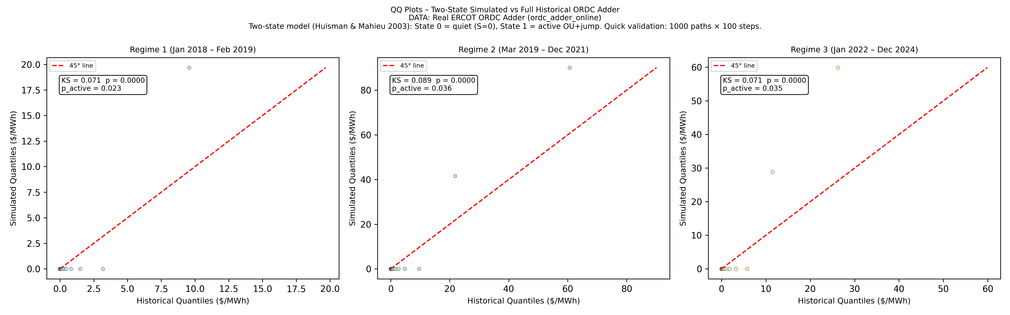
Figure 3: QQ plots comparing the simulated and historical ORDC adder distributions for each regime. A perfect model fit would follow the 45-degree diagonal. KS statistics of 0.07–0.09 indicate strong agreement across all three regimes.

Three things stand out in the calibration results. First, the ORDC adder is active in only 2 to 4 percent of all intervals across the three regimes. The portfolio sits idle in 96 to 98 percent of all 15-minute periods, with genuine scarcity pricing occurring only during that small fraction. This idle fraction roughly doubles during summer months, when air conditioning load puts the most pressure on reserve margins. This pattern is consistent with the core intuition from Section 1: demand response earns almost nothing most of the time.

Second, when spikes do occur, they are large. Average spike sizes of $450 to $1,329 per megawatt-hour above the activation cost reflect the fact that when the ORDC adder moves, it tends to move dramatically. Regime 3 shows the largest average spike sizes despite having the lower post-Uri price cap, suggesting that the weatherization requirements introduced after 2021 reduced how often spikes occur but not how severe they are when they do.

Third, switching to the two-state structure substantially improved how well the simulated price distribution matches the historical one. Before the switch, the comparison test between the two distributions scored 0.97, where zero means a perfect match and one means no match at all. After the switch, the score improved to 0.07 to 0.09 across the three regimes. The robustness checks using 2.5-sigma and 3.5-sigma jump thresholds showed that all key results are stable, with jump intensity varying by less than 15 percent across specifications.

6.2 Where the Value Actually Comes From
The most important finding in this paper is not a dollar figure. It is the degree to which the historical value of demand flexibility was concentrated in a single event. Table 2 breaks down the Regime 2 historical benchmark.

TABLE 2: HOW MUCH OF THE REGIME 2 VALUE CAME FROM WINTER STORM URI
Historical benchmark including Uri: $39,340/MW-year Historical benchmark excluding Uri: $20,204/MW-year Uri’s contribution: $19,136/MW-year Uri’s share of the total benchmark: 48.6% Uri duration: 80 hours (less than 1% of Regime 2 hours)

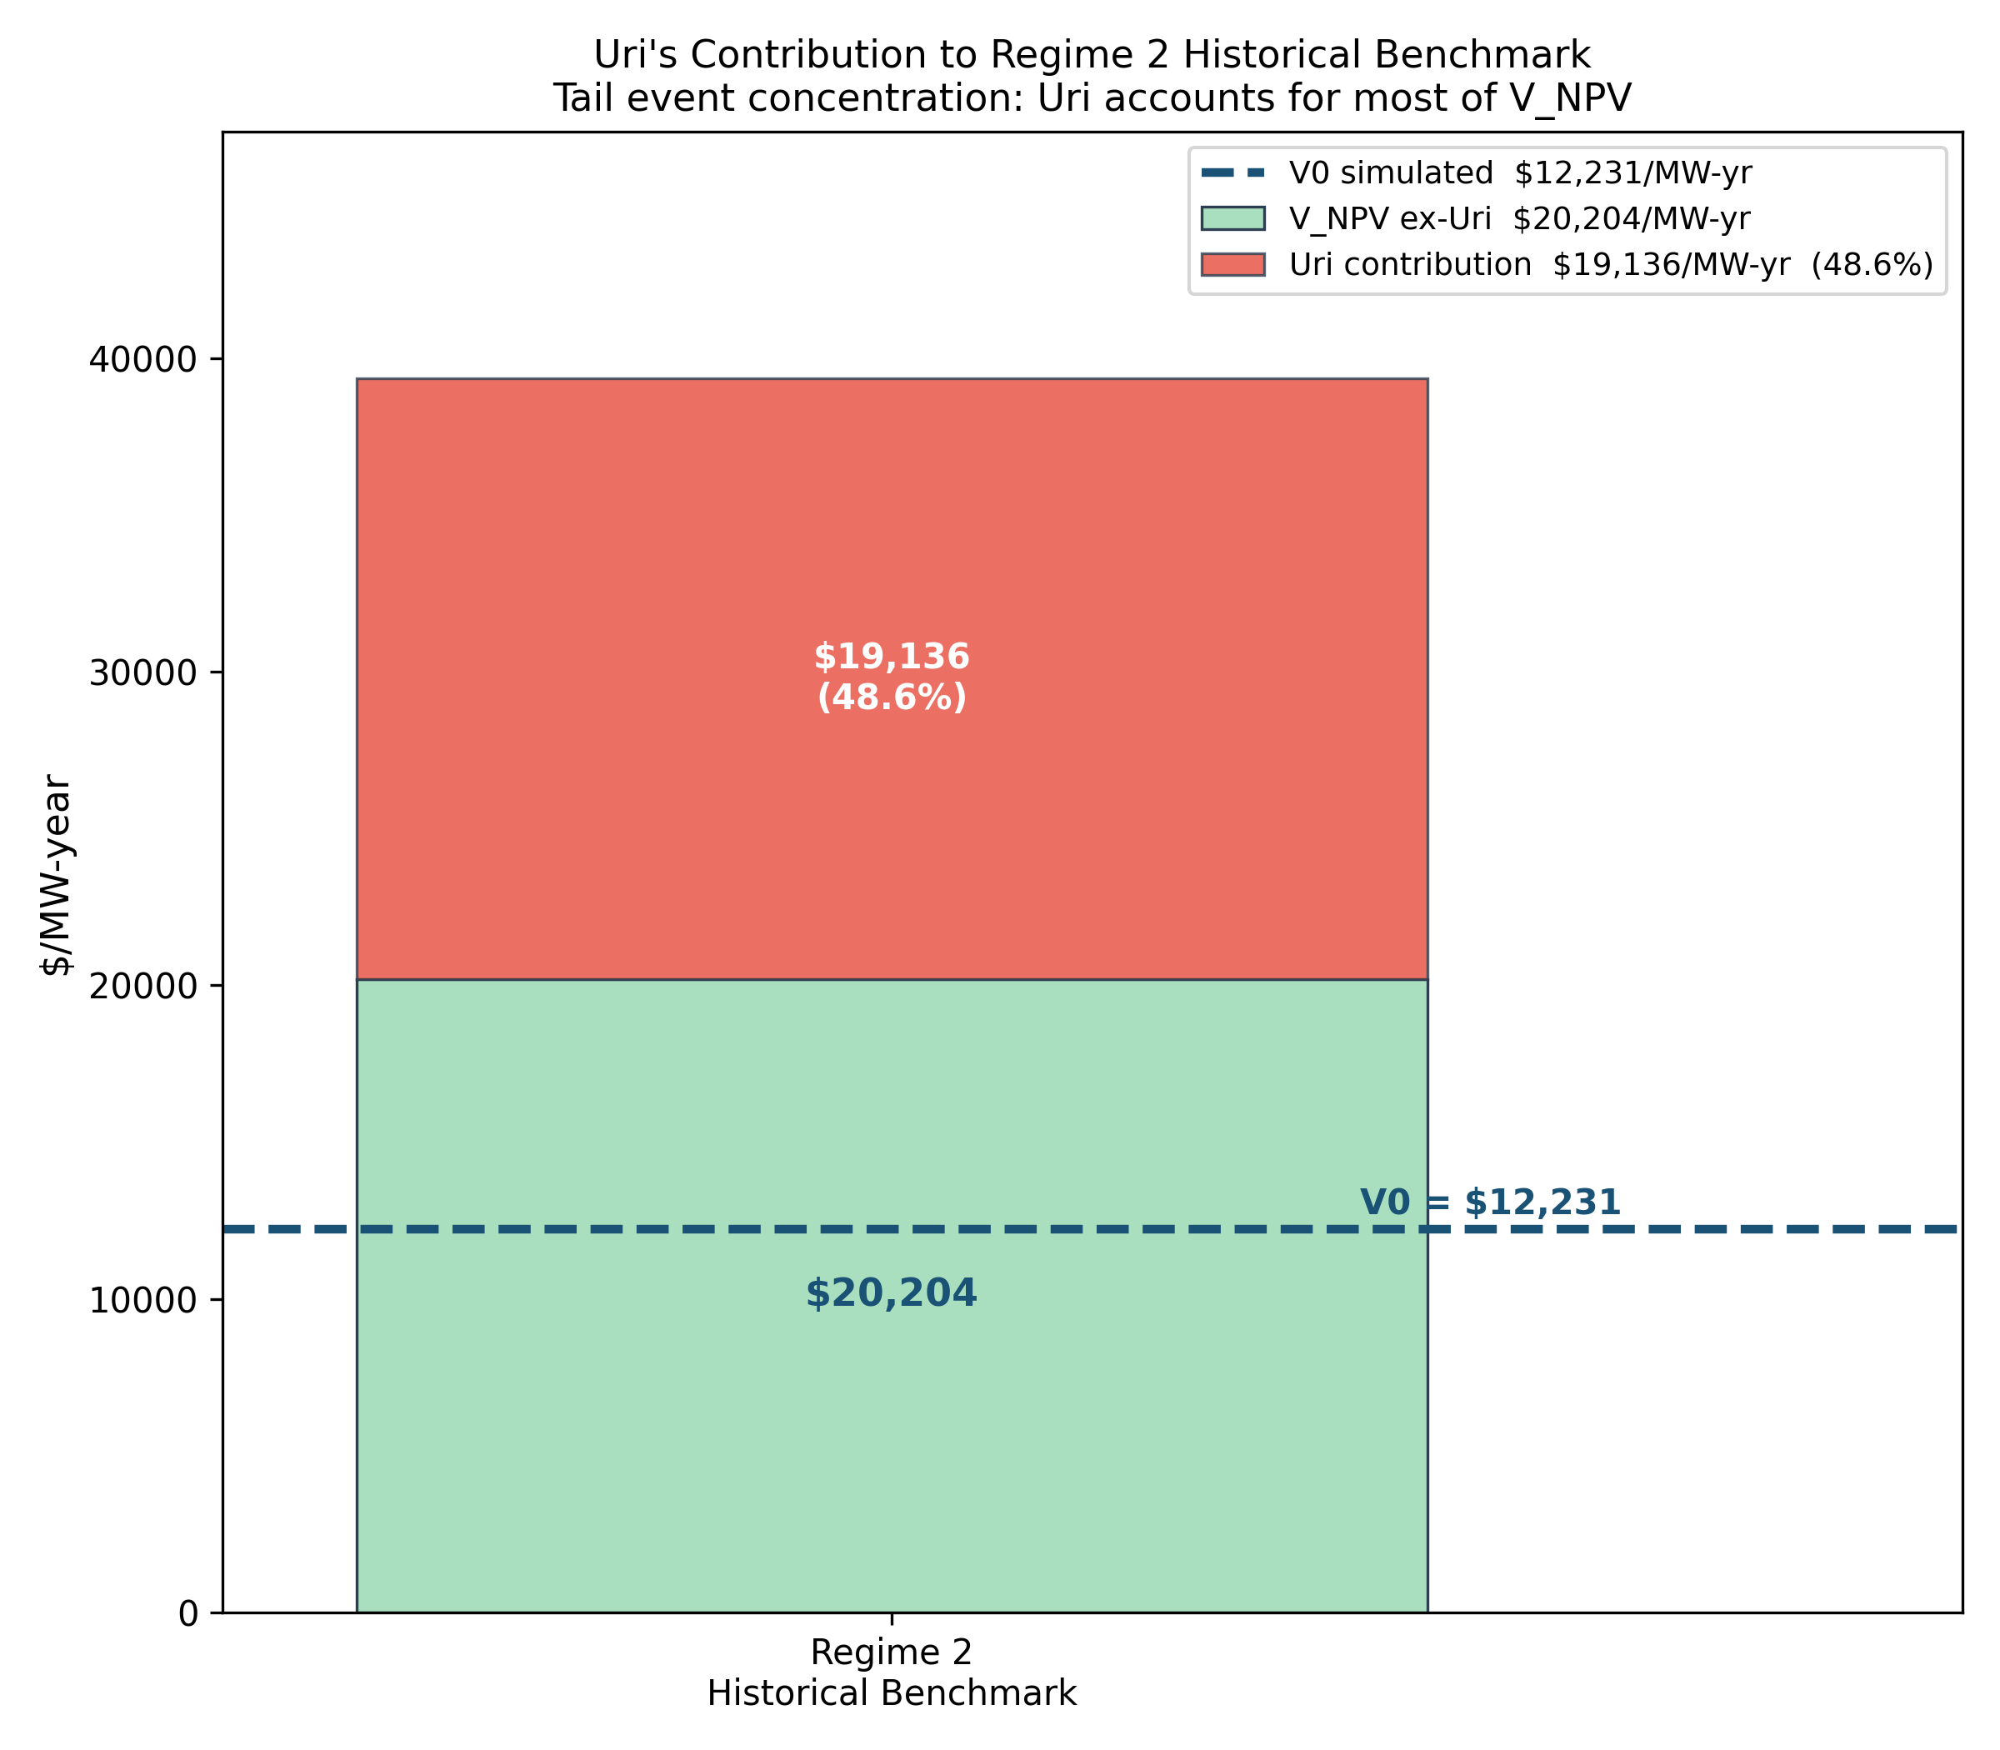
Figure 10: Decomposition of the Regime 2 historical benchmark showing the Uri contribution (upper segment) versus baseline scarcity value (lower segment). The horizontal line shows the forward-looking simulated option value V₀ for reference.

Winter Storm Uri lasted 80 hours, representing less than one percent of the hours in the three-year Regime 2 period. Yet those 80 hours contributed $19,136 per MW-year to the historical benchmark, nearly half of the entire period’s cumulative value. The remaining 26,000-plus hours of normal grid operations generated the other half.

This finding has a direct practical implication. A standard investment analysis conducted after 2021 using the full Regime 2 historical record would suggest a demand response portfolio should earn roughly $39,000 per MW-year going forward. The forward-looking simulation, fitted to typical active-period dynamics and excluding Uri from the parameter estimation, produces a much more conservative $12,231 per MW-year. Neither number is wrong. They answer different questions. The historical benchmark tells you what happened. The simulation tells you what to expect in a future year that does not contain a once-in-a-generation grid emergency.

The Uri stress test confirms the scale of the tail payoff directly. A portfolio that was active throughout the storm earned $1.26 million over 80 hours, equivalent to $138 million on an annualized basis. This is the asymmetric payoff that the option framing is designed to capture: almost nothing most of the time, and an extraordinary amount when the tail event occurs.

6.3 Forward-Looking Option Values
Table 3 presents the full comparison between simulated forward-looking values and historical benchmarks across all three regimes.

TABLE 3: SIMULATED OPTION VALUE VS HISTORICAL BENCHMARK ($/MW-YEAR, BASE CASE K = $50/MWH)
Regime 1: Simulated = $2,070 | Historical = $6,139 | Difference = −$4,068 (−66%) | 95% CI: [$2,057, $2,084] Regime 2: Simulated = $12,231 | Historical (with Uri) = $39,340 | Historical (without Uri) = $20,204 Regime 2 difference vs ex-Uri benchmark: −$7,973 (−39%) Regime 3: Simulated = $5,553 | Historical = $12,772 | Difference = −$7,218 (−57%) | 95% CI: [$5,526, $5,580]

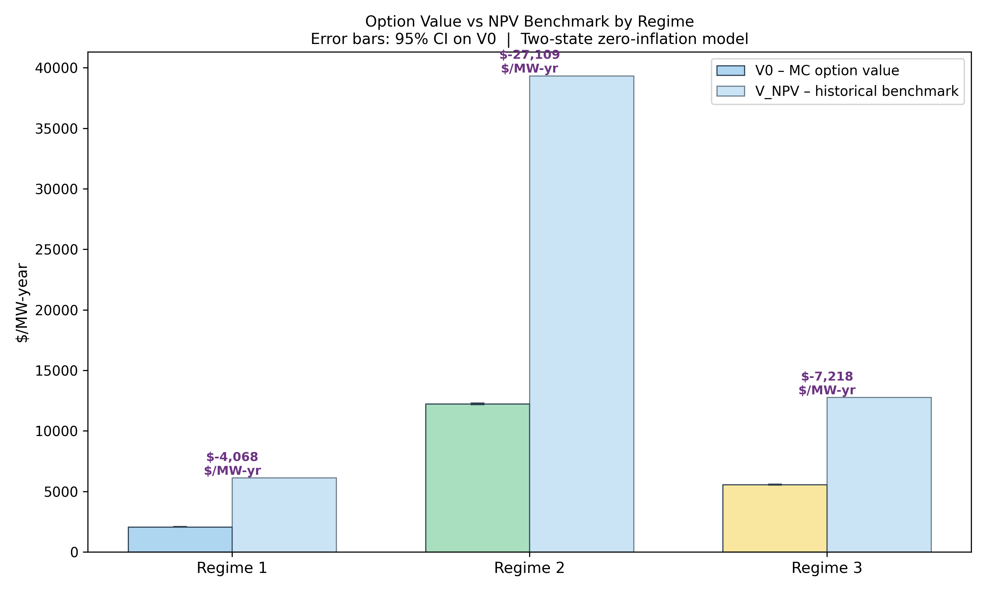
Figure 6: Grouped bar chart comparing simulated option value V₀ (dark) and historical benchmark V̂NPV (light) for each regime. I use green and yellow for regime 2 and 3 consistently across results. Error bars show 95% confidence intervals on V₀. Values expressed in $/MW-year.

The forward-looking simulated values are consistently below the historical benchmarks across all three regimes. This gap has two components. The first is the Uri effect in Regime 2. When Uri is removed from the Regime 2 benchmark, the gap narrows from 69 percent to 39 percent, showing how much of the Regime 2 discrepancy is driven by that single event rather than a systematic difference between the model and the market. The second component is genuine forward-looking conservatism: the fitted model represents typical scarcity conditions, and in a typical year without extreme tail events the expected payoff is meaningfully lower than any multi-year historical average that happened to include a major crisis.

The confidence intervals are tight across all regimes, with margins of error of $20 to $55 per MW-year, confirming that 10,000 simulation paths provide stable estimates. The three regimes also rank in the order the parameter changes from Section 3.4 would predict: Regime 2 is highest, Regime 3 intermediate, and Regime 1 lowest.

6.4 Sensitivity Analysis
The sensitivity sweeps produce three clean findings that hold across the full range of parameters tested.

Activation cost. As the cost of activating the portfolio rises, both the simulated value and the historical benchmark decline, because fewer intervals produce a profitable payoff. The gap between the two estimates persists across the full range from $10 to $200 per megawatt-hour. Resources with lower activation costs, such as automated industrial equipment, battery storage, and smart thermostats, capture meaningfully more value because they can profitably activate during lower-adder intervals that higher-cost participants must pass on.

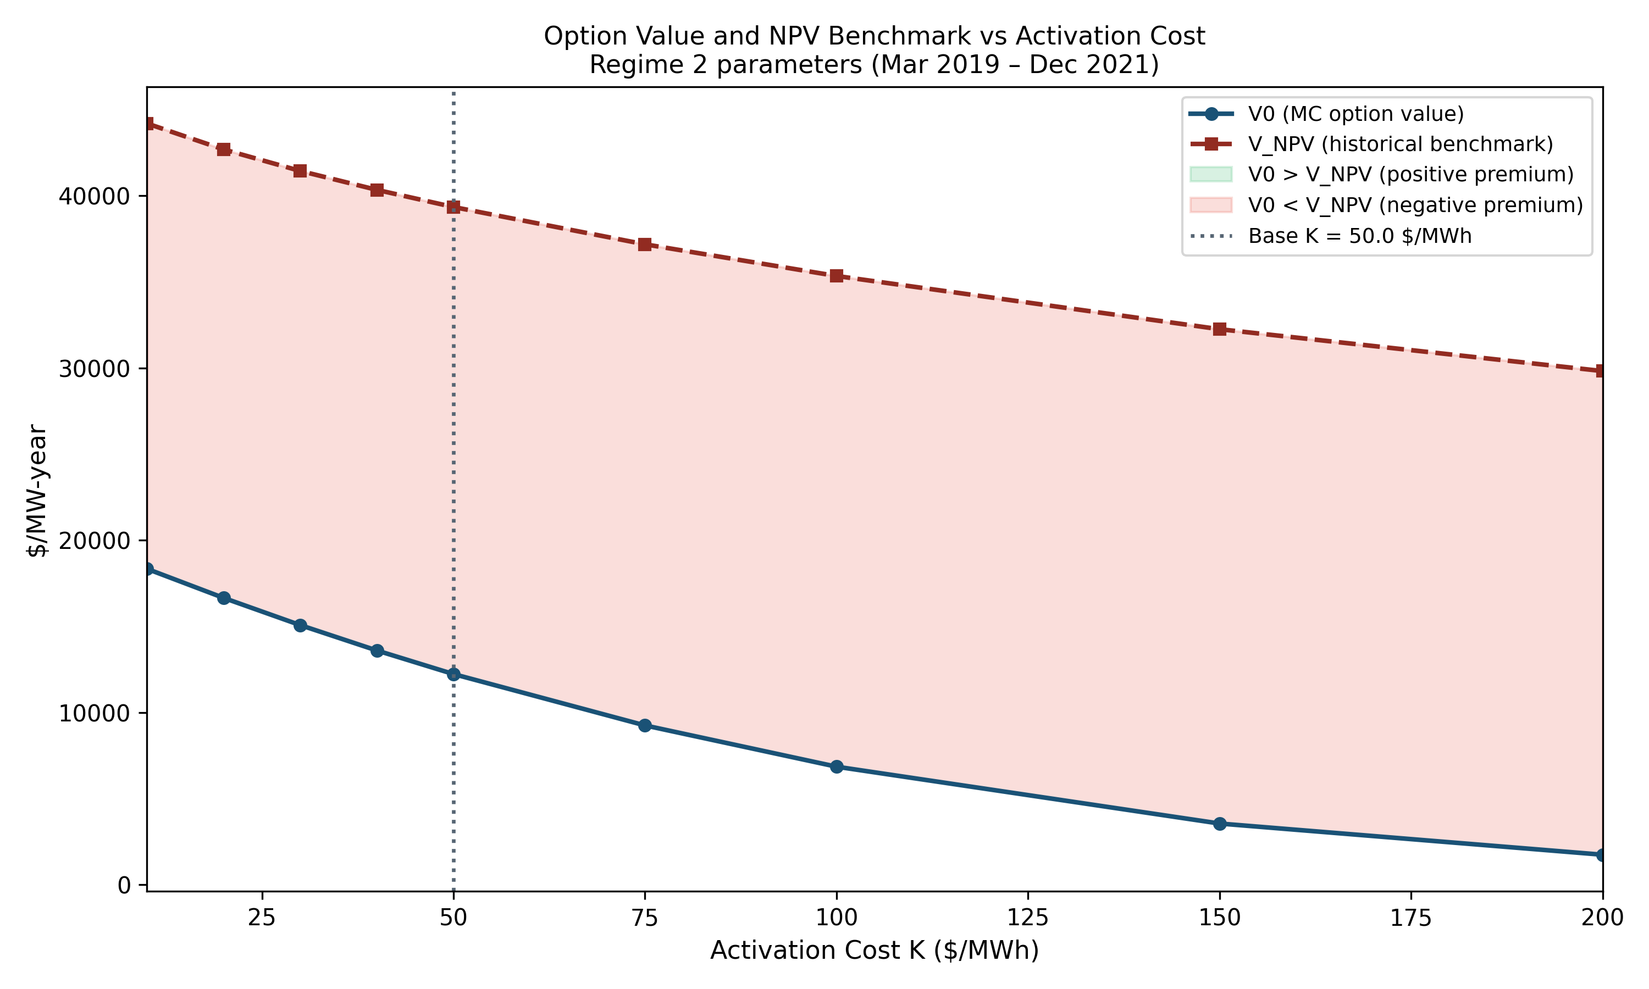
Figure 7: Simulated option value V₀ and historical benchmark V̂NPV as a function of activation cost K ($10–$200/MWh). The shaded area between the lines represents the valuation gap. The dashed vertical line marks the base case K = $50/MWh.

Portfolio size and availability. The simulated value per MW-year is nearly perfectly flat across all portfolio sizes from 10 to 500 loads and across all availability probabilities from 50 to 95 percent. This result is consistent with the linear scaling predicted by equation 4.1. The per-MW option value is independent of how large the portfolio is. A small aggregator with 10 loads earns the same return per MW as a large one with 500. The barrier to capturing scarcity value is not scale. It is activation cost and access to the right market products.

6.5 Vega: Volatility as the Primary Value Driver
The Vega analysis produces the paper’s clearest quantitative result. Table 4 reports the estimates by regime.

TABLE 4: HOW OPTION VALUE RESPONDS TO VOLATILITY (VEGA) BY REGIME
Regime 1: diffusion volatility = 18,470 (annualized), Vega = 0.215 $/MW-year per unit of volatility Regime 2: diffusion volatility = 23,876 (annualized), Vega = 0.724 $/MW-year per unit of volatility Regime 3: diffusion volatility = 18,720 (annualized), Vega = 0.391 $/MW-year per unit of volatility Ranking: the regime with the highest volatility produces the highest simulated option value across all three regimes.

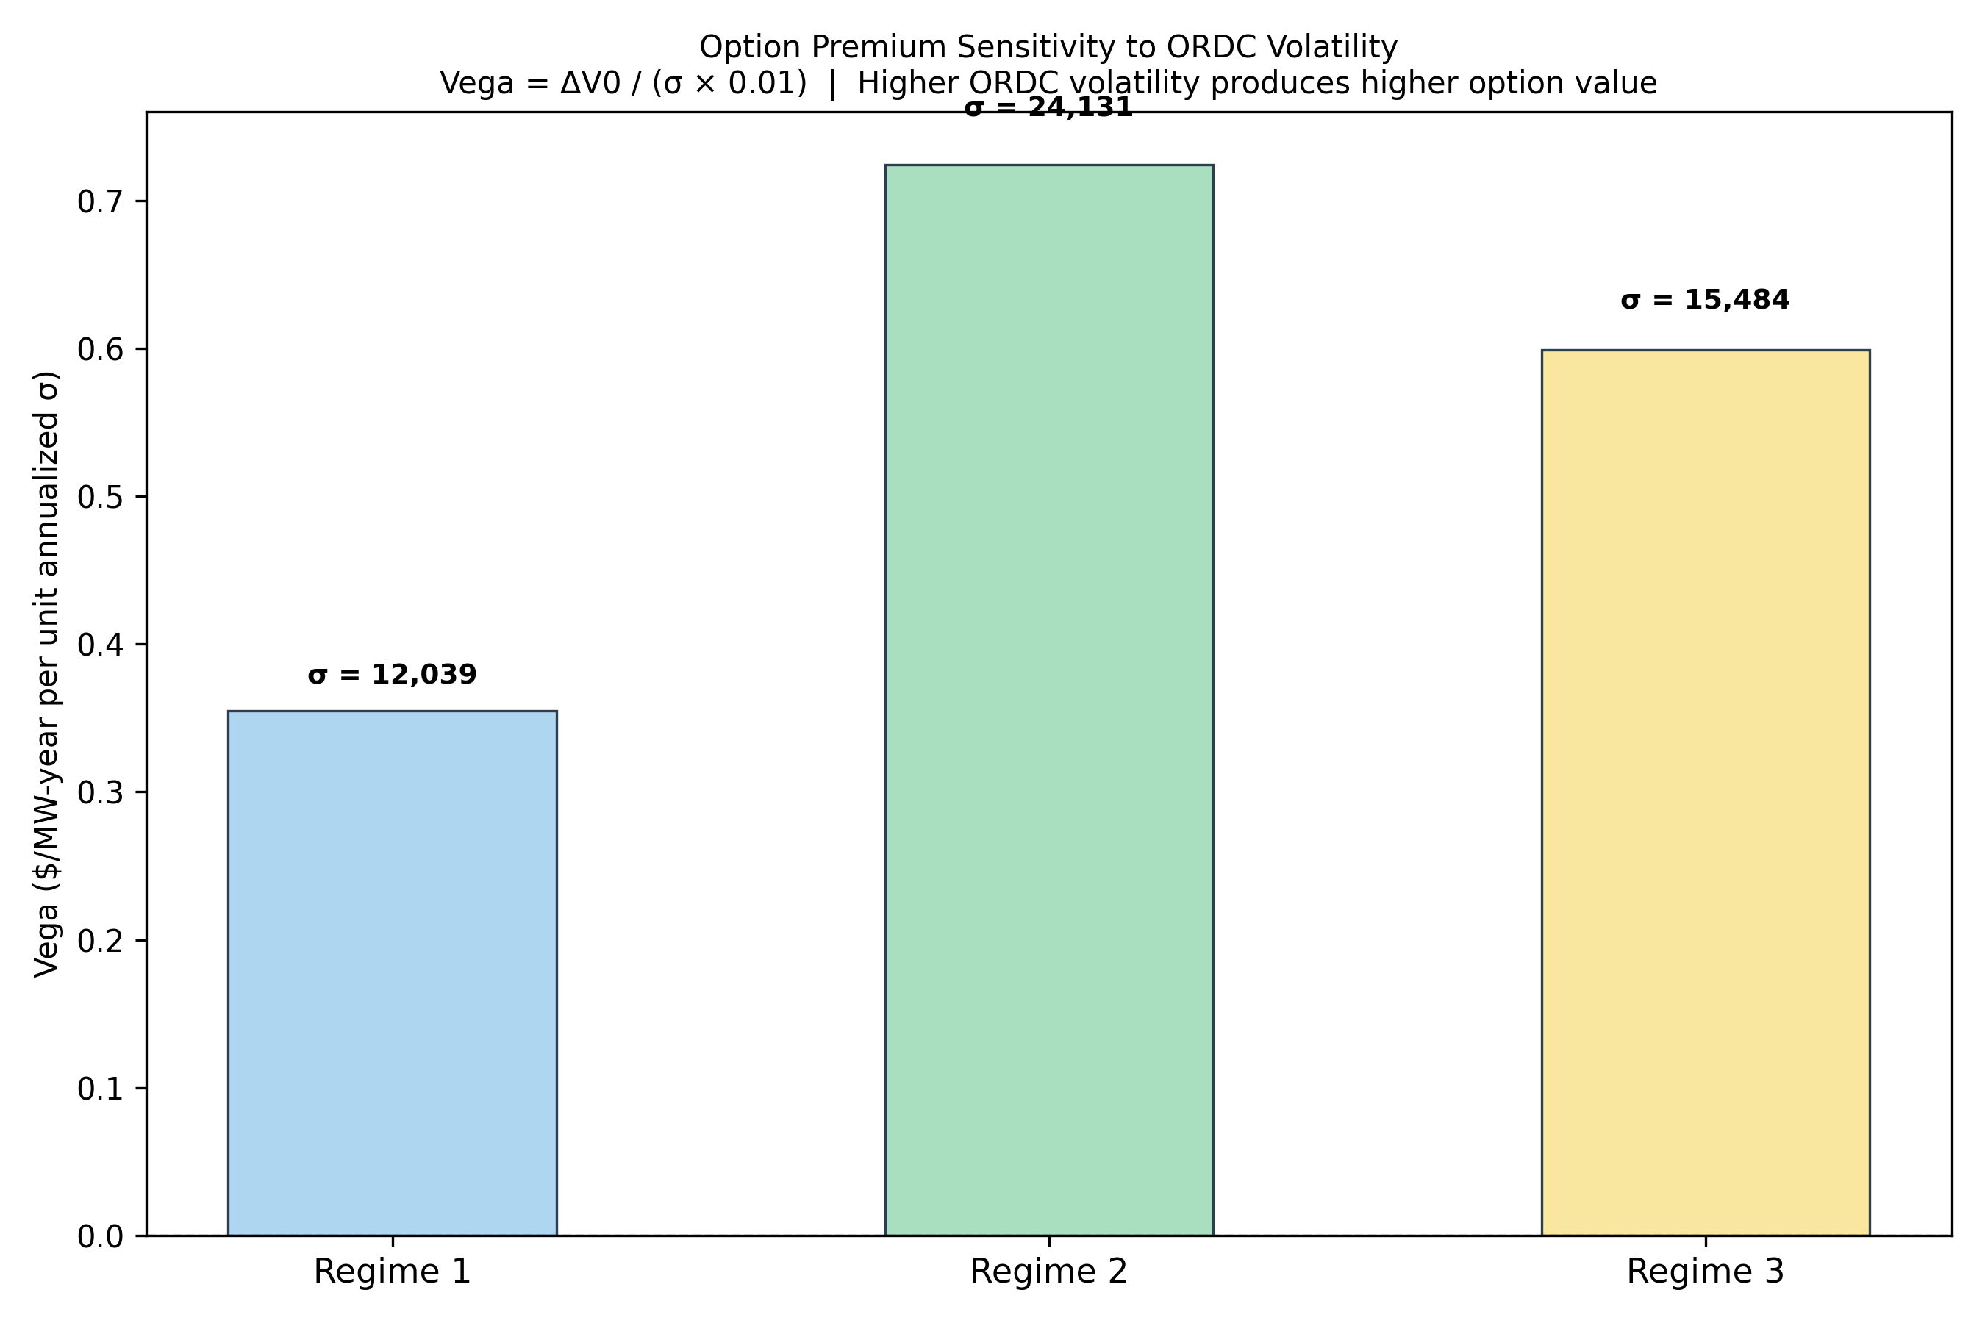
Figure 9: Vega estimates by regime. Each bar shows how much the simulated option value changes per unit increase in ORDC adder volatility. Regime 2, with the highest calibrated volatility, shows the largest Vega.

Vega is positive across all three regimes and largest in Regime 2, which has the highest volatility. Notably, the ranking is consistent across all three regimes: the regime with the highest volatility produces the highest option value, the regime with the lowest produces the lowest, and Regime 3 falls in between on both measures. These results are consistent with the paper’s central argument. Demand flexibility is worth most precisely in market conditions characterized by high scarcity price volatility, which are exactly the conditions that coincide with the highest reliability risk.

Regime 2’s Vega is roughly three times larger than Regime 1’s. This gap reflects not just higher volatility in Regime 2 but a nonlinear effect: as volatility rises, the probability of reaching the extreme price levels that generate the largest payoffs grows faster than proportionally, amplifying the sensitivity of the option value to the volatility level.

6.6 Summary of Findings
Three findings come out of the analysis. First, demand response value is highly concentrated in rare events. Less than one percent of the hours in Regime 2 generated nearly half of the total historical benchmark value. This means that conventional investment analysis, which treats historical averages as guides to future earnings, will systematically overstate expected returns in normal years while underweighting the value of being positioned for the next rare emergency.

Second, the forward-looking simulated values are meaningfully lower than historical benchmarks but remain significant, ranging from $2,070 to $12,231 per MW-year. The gap between the two reflects the difference between what happened, including a once-in-a-generation storm, and what a calibrated model expects in a typical future year.

Third, and most directly supporting the paper’s argument, simulated option value rises with market volatility across all three study periods. These results suggest that the mispricing identified in this paper is not a steady, uniform gap between market prices and fundamental value. It is a volatility-dependent payoff that is most pronounced in exactly the market conditions that matter most for grid reliability and that standard investment analysis most consistently fails to value correctly.

RESULTS: USE OF AI IN MODEL CODEBASE
A significant amount of the mathematical model codebase was generated with the assistance of Claude Code. My GitHub would be included in the project submission, and additional information is available upon request.

7. Discussion
The results of this paper carry implications that extend beyond the specific numbers reported in Section 6. This section discusses what the findings mean for investment decisions in demand flexibility, for the design of electricity markets, and for the potential development of financial instruments that would allow demand response aggregators to explicitly capture and trade the option value their portfolios embed.

7.1 What the Results Mean for Demand Response Investment
The most direct implication of this paper is that the tools used to evaluate demand response investments need to change. Standard cost-benefit analysis, which estimates the value of a demand response program as the discounted sum of expected activation payments, will produce estimates that are unreliable in two directions simultaneously. In periods following major grid emergencies, it will overstate expected future returns by embedding the emergency's realized payoff as a repeatable baseline. In normal periods with no recent extreme events, it may understate the option value of having demand flexibility available when the next emergency arrives.

The right approach is not to abandon historical data but to use it more carefully. The ex-Uri Regime 2 benchmark of $20,204 per MW-year and the forward-looking simulation estimate of $12,231 per MW-year bracket the likely range of true expected annual value under typical but not crisis conditions. The $7,973 gap between them represents residual model conservatism, since even the ex-Uri historical period contains non-Uri scarcity events that the calibrated model may underweight. A reasonable planning estimate for a demand response portfolio in a high-volatility ERCOT environment might sit between these two numbers.

The sensitivity analysis reinforces a practical point for aggregators building demand flexibility portfolios: activation cost is the most important lever. The gap between simulated and historical value persists across all activation cost levels, but the absolute payoff at any given market condition is highly sensitive to how cheaply a resource can activate. Automated resources with near-zero activation costs, including battery storage and smart industrial equipment with pre-configured curtailment protocols, are positioned to capture the most value from scarcity pricing. Manual demand response programs with high administrative activation costs will capture far less, regardless of portfolio size.

7.2 Implications for Market Design
The finding that ORDC adder value is concentrated in rare events has broader implications for how electricity markets should think about demand-side resources. ERCOT's energy-only design relies on scarcity pricing to attract and compensate reliability resources. The results of this paper suggest that scarcity pricing does generate substantial value for demand resources, but that value is delivered in a highly lumpy, unpredictable way that makes it difficult for potential investors to evaluate. A demand response aggregator considering whether to build a portfolio faces a fundamental forecasting problem: the value depends critically on whether a Winter Storm Uri-scale event occurs during the investment horizon, and that probability is genuinely uncertain.

One response to this problem is to design financial instruments that allow aggregators to smooth or hedge their exposure to tail events. FERC Order 2222's opening of wholesale markets to demand resource aggregations created the regulatory foundation for such instruments, but the financial engineering has not followed. The results of this paper suggest there is a real economic basis for ORDC-contingent contracts, in which an aggregator receives a fixed annual payment in exchange for committing to provide curtailment capacity during scarcity events above a defined threshold. Pricing such a contract using the framework developed in this paper, with the ORDC adder as the underlying and the commitment threshold as the strike price, is a natural extension of the methodology presented here.

More broadly, the tail concentration finding is relevant to resource adequacy planning. If nearly half of the realized reliability value from demand response in a three-year period came from 80 hours during one storm, then resource adequacy assessments that rely on average contribution metrics will systematically undercount the reliability value of demand-side resources. Reliability metrics that account for the extreme event contribution, analogous to conditional value-at-risk in financial risk management, would provide a more accurate picture of how much demand flexibility contributes to system security.

7.3 Limitations
Several limitations of this analysis should be acknowledged clearly. The demand response portfolio is specified parametrically rather than calibrated to real program data. The activation cost, availability probability, and portfolio size used in the base case are plausible but not derived from observed program performance. Real programs face additional constraints, including minimum notification times, maximum annual activation hours, and customer attrition over time, none of which are modeled here. The simulated option values should therefore be interpreted as upper bounds on what a well-designed program could achieve under the modeled market conditions.

The stochastic model of ORDC adder dynamics, while substantially improved by the two-state structure, remains a simplification. The Euler discretization of the continuous-time SDE introduces approximation error, and the calibrated parameters are treated as fixed within each regime rather than as evolving processes. The two-state Bernoulli specification for state selection is a tractable approximation to a continuous-time regime-switching model, and future work using a Markov-switching specification would allow transition probabilities to vary with observable grid conditions such as reserve margin levels or weather forecasts. Finally, this analysis does not model strategic behavior by market participants. At scale, large demand response aggregators could affect equilibrium ORDC prices through their activation decisions, an effect that is beyond the scope of this framework.

8. Conclusion

This paper set out to answer a question that sits at the intersection of power systems operations and quantitative finance: is demand-side flexibility correctly priced by conventional investment analysis? The answer this paper offers is nuanced. Conventional analysis is not simply wrong. It is asking the wrong question.

Standard net present value analysis asks what a demand response portfolio earned historically and uses that as a guide to future value. This paper shows that the historical record is a poor guide, because demand response value is dominated by rare tail events. Less than one percent of the hours in the highest-volatility study period generated nearly half of the total historical benchmark value. No investment methodology that treats historical averages as repeatable baselines will capture this structure correctly.

The right question is not what demand response earned, but what it is worth as a contingent asset whose value is highest precisely when grid reliability is most at risk. The option pricing framework developed here answers that question. By formally characterizing the ORDC adder as the underlying asset, calibrating its dynamics to seven years of ERCOT real-time data, and pricing the demand response portfolio as a call option through Monte Carlo simulation, this paper produces forward-looking value estimates that are grounded in the statistical properties of scarcity pricing rather than in the accident of which extreme events happened to fall within the sample window.

Three findings anchor the paper's contribution. First, the two-state model structure, which separates the 96 to 98 percent of intervals where the ORDC adder is at or near zero from the active scarcity pricing intervals, is essential for producing credible simulations. Without it, standard calibration techniques produce nonsensical parameters. This finding has methodological implications for any future empirical work on ORDC-based pricing.

Second, the Uri decomposition establishes that nearly half of the Regime 2 historical benchmark came from 80 hours of a once-in-a-generation storm. This finding has direct practical implications for anyone using post-2021 historical data to evaluate demand response investments: that data embeds Uri's contribution as a baseline, and a forward-looking analysis should not.

Third, and most central to the paper's thesis, simulated option value rises consistently with ORDC volatility across all three study regimes. Demand flexibility is worth most when the market is most volatile, which is when reliability risk is most elevated. This alignment between private option value and public reliability benefit is precisely the economic property that a well-designed scarcity pricing mechanism should produce, and these results suggest that ERCOT's ORDC does produce it, even if conventional investment frameworks fail to measure it.

The practical implication is straightforward. Investors, utilities, and policymakers evaluating demand response should use forward-looking simulation frameworks calibrated to typical market dynamics, not historical averages inflated by extreme events. They should focus on minimizing activation costs rather than maximizing portfolio size. And they should recognize that the option value embedded in demand flexibility, while lower in expectation than historical benchmarks imply, is real, measurable, and most pronounced in exactly the market conditions that matter most for the reliability of the grid.

References

Borenstein, S. (2005). The long-run efficiency of real-time electricity pricing. The Energy Journal, 26(3), 93–116.
Cartea, Á., & Figueroa, M. G. (2005). Pricing in electricity markets: A mean reverting jump diffusion model with seasonality. Applied Mathematical Finance, 12(4), 313–335.
Dixit, A. K., & Pindyck, R. S. (1994). Investment under uncertainty. Princeton University Press.
FERC. (2011). Demand response compensation in organized wholesale energy markets (Order No. 745). Federal Energy Regulatory Commission.
FERC. (2020). Participation of distributed energy resource aggregations in markets operated by regional transmission organizations and independent system operators (Order No. 2222). Federal Energy Regulatory Commission.
FERC. (2021). Assessment of demand response and advanced metering. Federal Energy Regulatory Commission.
Faruqui, A., & Sergici, S. (2010). Household response to dynamic pricing of electricity: A survey of 15 experiments. Journal of Regulatory Economics, 38(2), 193–225.
Faruqui, A., Sergici, S., & Akaba, L. (2014). The impact of dynamic pricing on residential and small commercial and industrial usage. The Energy Journal, 35(1), 149–168.
Geman, H., & Roncoroni, A. (2006). Understanding the fine structure of electricity prices. Journal of Business, 79(3), 1225–1261.
Hirst, E., & Kirby, B. (2001). Retail-load participation in competitive wholesale electricity markets. Edison Electric Institute / EPRI.
Hogan, W. W. (2005). On an ‘energy only’ electricity market design for resource adequacy. Harvard Kennedy School Working Paper.
Huisman, R., & Mahieu, R. (2003). Regime jumps in electricity prices. Energy Economics, 25(5), 425–434.
Joskow, P. L. (2006). Competitive electricity markets and investment in new generating capacity. MIT Center for Energy and Environmental Policy Research Working Paper 06-009.
Joskow, P. L. (2008). Capacity payments in imperfect electricity markets: Need and design. Utilities Policy, 16(3), 159–170.
Lucia, J. J., & Schwartz, E. S. (2002). Electricity prices and power derivatives: Evidence from the Nordic Power Exchange. Review of Derivatives Research, 5(1), 5–50.
Oren, S. S. (2005). Generation adequacy via call option obligations: Safe passage to the promised land. The Electricity Journal, 18(9), 28–42.
Schwartz, E. S. (1997). The stochastic behavior of commodity prices: Implications for valuation and hedging. Journal of Finance, 52(3), 923–973.
Weron, R. (2006). Modeling and forecasting electricity loads and prices: A statistical approach. Wiley Finance Series.
Wolak, F. A. (2011). Do residential customers respond to hourly prices? Evidence from a dynamic pricing experiment. American Economic Review, 101(3), 83–87.

Appendix: Key Terms and Concepts Explained

This appendix is intended for readers who may not have a background in electricity markets or financial mathematics. It provides plain-language explanations of the key concepts used throughout the paper. You do not need to read this before starting the paper, but it is here as a reference whenever a term needs more context.

A.1 Electricity Market Basics
Electricity grid. The network of power plants, transmission lines, and distribution systems that delivers electricity from where it is generated to where it is consumed. The grid must be kept in continuous balance: generation must equal consumption at all times, or the system can fail.

Operating reserves. A buffer of backup power that grid operators keep available at all times in case a generator unexpectedly trips offline or demand is higher than expected. Think of it as a spare tire: you hope you never need it, but the grid cannot safely operate without it.

ERCOT. The Electric Reliability Council of Texas, which operates the electricity grid serving most of Texas. ERCOT manages the real-time balancing of supply and demand, runs the wholesale electricity market, and publishes the pricing data used in this paper.

Wholesale electricity market. The market where electricity generators sell power to utilities and large buyers. Prices are set by supply and demand in real time, typically every five minutes. This is different from the retail electricity bill that households receive, which is based on averaged wholesale costs.

Locational marginal price (LMP). The real-time price of electricity at a specific location on the grid, reflecting the cost of serving the next megawatt of demand at that point. LMPs can vary significantly across locations and across time.

Megawatt (MW) and megawatt-hour (MWh). A megawatt measures power, which is the rate of electricity flow. A megawatt-hour measures energy, which is what you get when you use one megawatt of power for one hour. Electricity prices are quoted in dollars per MWh, similar to how gas prices are quoted per gallon.

A.2 ORDC and Scarcity Pricing
Operating Reserve Demand Curve (ORDC). A pricing mechanism used by ERCOT that automatically adds a scarcity premium on top of the regular electricity price whenever operating reserves fall below comfortable levels. The size of the adder depends on how low reserves are: the lower the reserves, the higher the adder. This paper models and analyzes the behavior of this adder.

ORDC adder. The additional dollar amount added to the electricity price by the ORDC mechanism. When the grid has plenty of reserves, this adder is near zero. When reserves are tight, it can reach thousands of dollars per megawatt-hour.

Value of Lost Load (VOLL). An estimate of how much economic damage is caused by a one-hour electricity blackout affecting one megawatt of load. ERCOT used a VOLL of $9,000/MWh before 2022 and $5,000/MWh after regulatory reforms following Winter Storm Uri. The ORDC adder can never exceed the VOLL.

Loss of Load Probability (LOLP). The probability that the grid will be unable to meet all electricity demand at a given moment, typically because reserves have fallen below the emergency threshold. The ORDC adder is calculated as VOLL multiplied by the LOLP.

Capacity market. A separate market, used by most U.S. grids but not ERCOT, in which generators are paid just for agreeing to be available, regardless of whether they actually produce power. ERCOT's absence of a capacity market means all reliability value must be recovered through energy and ancillary service prices.

Ancillary services. Reliability services that grid operators procure to maintain system stability, beyond just buying energy. Examples include Responsive Reserve Service (fast emergency response), Regulation Service (continuous frequency control), and Non-Spinning Reserve (backup available within 30 minutes).

A.3 Demand Response
Demand response (DR). Programs that pay electricity users to voluntarily reduce their consumption during periods of grid stress or high prices. Rather than always building more power plants to meet peak demand, demand response uses the demand side of the equation as a flexible resource.

Demand response aggregator. A company that bundles together the flexible electricity use of many individual customers, such as factories, office buildings, or homes, into a portfolio large enough to participate meaningfully in wholesale electricity markets. Individual customers are typically too small to participate on their own.

Activation cost. The cost to an aggregator of actually calling on a customer to reduce their electricity use. This includes any payment made to the customer, operational costs, and the value of whatever the customer had to give up by curtailing. In this paper, the base case activation cost is $50/MWh.

Curtailment. The act of reducing electricity consumption. When a demand response aggregator activates a portfolio, it is curtailing load, freeing up capacity that can be sold into the market.

A.4 Financial Options Concepts
Financial option. A contract that gives its holder the right, but not the obligation, to buy or sell something at a predetermined price on or before a specified date. The key feature is discretion: the holder can choose whether to act based on whether it is profitable to do so. If conditions are unfavorable, the holder can simply let the option expire unused.

Call option. A specific type of option that gives its holder the right to buy an asset at a fixed price (the strike price). If the market price rises above the strike price, the holder exercises the option and profits from the difference. If the market price stays below the strike, the holder does nothing. Demand response in this paper behaves like a call option: it pays off when the ORDC adder rises above the activation cost.

Strike price. The predetermined price at which an option holder can act. In the context of this paper, the activation cost K plays the role of the strike price: the aggregator only activates when the ORDC adder exceeds K.

Option premium. The price paid to acquire an option, or more generally the additional value that comes from holding a discretionary, contingent instrument rather than a fixed commitment. This paper estimates the option premium embedded in demand response portfolios.

Real options theory. An extension of financial option pricing to physical investment decisions. It recognizes that many investment opportunities share the key features of options: some upfront cost that is difficult to reverse, uncertain future payoffs, and the ability to choose when and whether to commit. Demand response investment satisfies all three conditions.

A.5 Modeling and Simulation Concepts
Stochastic process. A mathematical model that describes how a quantity evolves over time in a random way. This paper models the ORDC adder as a stochastic process that tends to revert to low levels (mean reversion) but occasionally jumps to large values (jump process).

Mean reversion. The tendency of a price or quantity to return to its long-run average after moving away from it. Electricity scarcity prices exhibit strong mean reversion: after a spike caused by a generator outage, prices typically return to normal levels once reserves are restored.

Monte Carlo simulation. A computational technique that estimates the value of something uncertain by running thousands of simulations of possible future scenarios and averaging the results. In this paper, 10,000 simulated years of ORDC adder paths are generated, the payoff is calculated for each, and the average gives the estimated option value.

Calibration. The process of fitting a mathematical model to real data by estimating its parameters. In this paper, calibration involves estimating five parameters of the stochastic process from historical ERCOT data, separately for each of the three study periods.

Vega. A measure of how sensitive an option's value is to changes in price volatility. A positive Vega means the option becomes more valuable when prices are more volatile. This paper finds that demand response option value has a positive Vega across all three study periods, meaning it is worth most in the most volatile, highest-stress market conditions.

Net present value (NPV). A standard investment analysis method that estimates the value of an investment as the sum of its expected future cash flows, adjusted (discounted) for the time value of money. NPV works well for assets with predictable cash flows but is poorly suited to assets like demand response whose value is concentrated in rare tail events.

